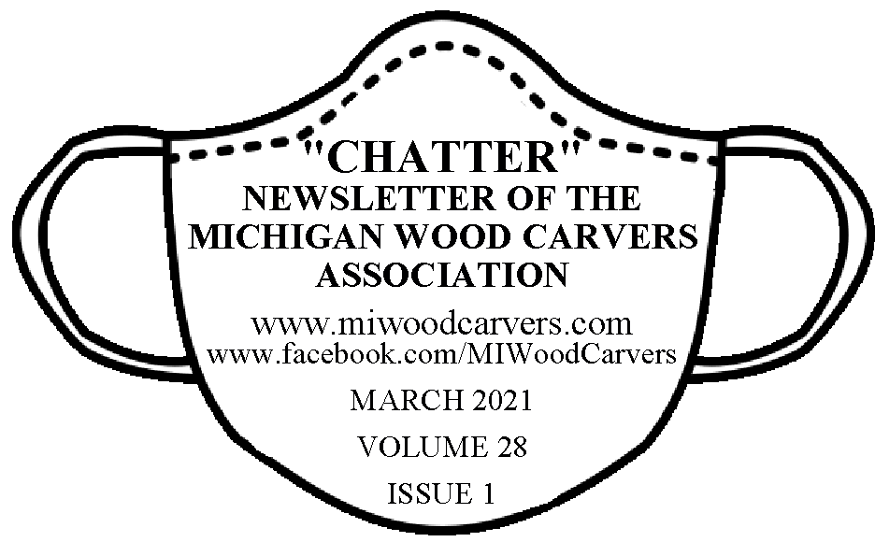

CLUB NEWS CANE REPORT PRESIDET’S REPORT
From your President:
NOTICE: Greetings to all MWCA carvers. Willy Stewart has decided to step down from the Association’s Secretary position, effective as soon as a replacement could be nominated. As such, a decision was made last December by the Board members that we would nominate Harry Dryer to fill the position. He has accepted. We thank Willy for his many years of faithful service.
February 23, 2021
I hope this finds all of our carvers and their families well (as well as can be expected during these troubled times). I was very pleased that we might be having a Metro Show this year. Please don’t blame others for cancelling their shows; most of the time it was the venue that didn’t allow large gatherings.
The Mid-Michigan WoodCarvers have moved! Our new mailing address is P.O. Box153, Corunna, MI 48817. We are still in the moving process, but we are now meeting in our new location. Thursday carving has been suspended until further notice, but we are meeting on Tuesdays from noon-7:00 PM every week.
Our physical location is the building at 2276 East M-21, on the south side of the road between 5/3 Bank & JellyBeans, across from Home Depot. We are going to try and have a small show here in the summer in a tent. Any ideas?
The Patriot Cane program is still making and delivering canes. We still need any finished eagle heads that you can provide; blanks are available by calling Denny at 989-277-5739, or e-mail him at vetcane2@gmail.com. We will mail them if needed.
We are pleased to announce that Mid-Michigan WoodCarvers are joining with Cedar Bird Shop to provide a place for people to check out carving tools and supplies at our new club location.
Be Careful, Be Safe
Denny

CARVING CLUB NEWS
SALINE CARVERS: https://salinecarversblog.wordpress.com/
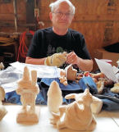
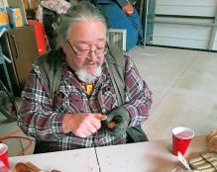
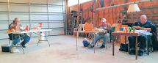

METRO CARVERS: It is now official. Metro Carvers of Michigan is holding our 40th carving show. Yest it was supposed to be March of 2021, but.......it will be held Saturday and Sunday October 23-24, 2021 at the United food and Commercial Workers Union Hall, 876 Horace Brown Drive, Madison Heights, MI 48071. Our club leaders are enthused and suspect there is a big pent-up desire for any carving event. Further details will be coming out soon, including times, table rental information and more. Our show chair ladies are Sharon Hill, Sharon0229@att,net, 586-557-3712 and Sandra Doran sandradoran@aol.com. Sharon is the primary contact for inquiries about table rental information and more.
TRI-CITY CARVERS: Our annual Antique Warehouse display was a major success, with some very positive feedback from the public to the staff. Seems they really like our display and I personally feel it is the best display they have all year. It was fun just dropping off carving for the display, we all stood there chatting up a storm and blocking the lobby, lol.
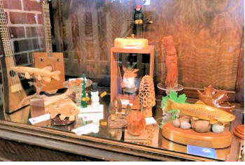
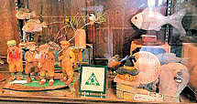

At the present time we are in the process of planning our August Carving show.

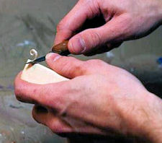
BEGINNER CARVING TIP FROM TRI CITY CARVERS: No matter what carving method you’re following or what tool you’re using – it is essential always to know where the edge of the blade and the tip is. This is not only about where the tip is, but where it is going. If you aim the blade of a knife towards a leg or hand, for example, you may end up slipping and harming yourself. The same happens if you’re pointing towards another part of the piece or through the piece you’re working on – which could lead to a nasty mistake. Hold the piece firmly (WEAR A GLOVE!!!) and cut away from you when you can, pushing the blade with your thumb. Calculating correctly before making a cut is so important. You’ll end up a better carver with way better results. Based loosely on an article from the Tool Specialist. Photo from the internet not identified.

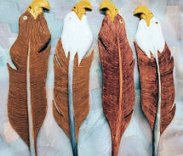
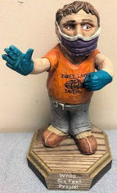
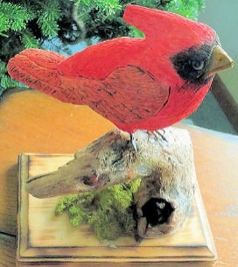
COVID CARVINGS:
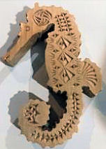
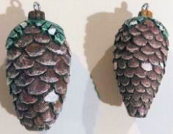
Ivan Thane-TriCity Pooch-Saline Tom Jacobson-Saline Mike Basner-TriCity
CHIPS & CHATTER

2021-2022 MWCA MEMBERSHIP: Because of the Covid pandemic all clubs that paid membership dues to 2021, dues will be waived for 2021-2022. All paid members on your roster for 2021 will be paid to 2022. I believe most clubs are in sort of limbo right now, not many having carving get-togethers until Covid subsides. But keep up the carving and when a lot of us have our vaccines we will probably start getting together again.

WOOD CARVERS ROUNDUP has been postponed till next year. Due to the unpredictable Covid situation and safety of everyone it was decided it was best to wait another year when hopefully things will be back to normal and everyone is vaccinated. Due to the fact that most workshop leaders plan far in advance for supplies it was only fair to give them time to adjust. It will give folks time to plan other activities for their summer also. See you all next year!
FLOYDFEST CARVING SEMINAR has also been cancelled but rescheduled for September 13-17 at the Osceola County Fairgrounds, replacing Spit and Whittle for this year. We are planning on whittling again in 2022 when things are more certain. Contact Floyd for more information rhads134@comcast.net, 734-649-3259

CARVING OPPORTUNITY for on-line and face-to-face. With members of the Oakland/Livingston Wood Carvers. There is a cost for each class.
In-Person Intro to Chip Carving (if Covid will allow) with Herman Marquart Starts on March 5th with 6 weekly session. (Wear your mask). For beginning chip carving Herman will lead you step-by-step through planning, designing, and practicing your chip carving technique to use on furniture, doors or anywhere your imagination guides you. Classes held at the Clarkston Sr Center.
Zoom Class on Comfort Bird Carving with Gerry Burchard starts on April 8th, with 4 weekly sessions for beginners. Gerry will lead you step-by-step through planning, carving and finishing your Comfort Bird.
Zoom Class on Eagle Head Canes for Vets with Gerry Burchard. Part 1, 4 classes in May (Drawing lines/Roughing in). Part 2, 4 classes in June (Rounding/details/woodburning). Part 3, 4 classes in July ending in August (Painting/finishing and submission to Lean On Me Program (optional).

Each class 30 minutes instruction and 60 minutes carving with instructor.
For more information on any of the classes call Gerry Burchard 248-941-1843. Email: glburchard@yahoo.com
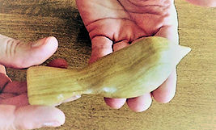
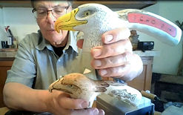
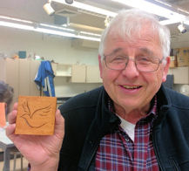

THE “CHATTER” NEWSLETTER GOES OUT BY E-MAIL ONLY on or about the first the months listed below. All news to be included needs to be to the editor, Sandy Holder by the 25th of the month prior to publication. E-Mail and phone listed below. You can always download or read a PDF on the MWCA website at www.miwoodcarvers.com
I NEVER THOUGHT THE COMMENT “I WOULDN’T TOUCH THEM WITH A SIX-FOOT POLE” WOULD BECOME A NATIONAL POLICY, BUT HERE WE ARE!
I HAVEN’T CUT MY HAIR SINCE THE QUARANTINING STARTED. YESTERDAY I STEPPED ON A SCALE FOR THE FIRST TIME IN A WHILE. WHO KNEW THAT HAIR WEIGHS SO MUCH?

Please share this newsletter with the rest of your members who don’t receive it by email and FORWARD THE NEWSLETTER BY EMAIL to your club members who have email. Thank you.
CHATTER NEWSLETTER IS PUBLISHED ON OR AROUND THE FIRST OF
JANUARY MARCH MAY JULY SEPTEMBER NOVEMBER

2021 MWCA COMING EVENTS
2021 | EVENTS PLANNED (What we know right now) | LOCATION | INFORMATION
March | METRO CAVING SHOW | Rescheduled for October
6/16-19 | EVART ROUNDUP | Cancelled till 2022 | 734-649-3259
6/21-25 | FLOYDFEST SEMINAR | Rescheduled to Sept | 734-649-3259
8-? | TRI CITY CARVING SHOW
9/16-18 | SPIT & WHITTLE WEEKEND | Cancelled till 2022
9/13-17 | FLOYDEFEST | Evart Fairgrounds | 734-649-3259
10/23-24 | METRO CARVING SHOW | Food Workers Hall-Madison Hgts | 586-557-3712

MWCA BOARD AND COMMITTIES
President  Denny Sekrenes  989-277-5739  Vetcane2@gmail.com | Vice President and Learning Seminar  Dave Sanderson  989-339-6444 sandersonwoodart@yahoo.com | Secretary  Harry Dryer  989-292-0460  Harry.mwca@gmail.com | Treasurer  Christie Garant  210-787-8614  clgarant@gmail.com
“Chatter” Editor  Sandy Holder  231-250-3855  mwcanews@gmail.com | MWCA Chaplain  Arnold Tew  269-781-7852  arnval177@gmail.com | Judging  Phyllis Burghy  989-928-4242  cedarbirdshoppe@charter.net | Promotional (Calendars, etc.)  Denny Sekrenes  989-277-5739  Vetcane2@gmail.com
Patriot Cane Project  Mid-Michigan Carvers  Denny Sekrenes  989-277-5739  Vetcane2@gmail.com | Webmaster  Justin Swanson  616-446-0120  Justin.john.swanson@gmail.com  Administrative Tech: (web & IT for cane project)  Harry Dryer  989-292-0460  Harry.mwca@gmail.com | Insurance  Sharon Seitz  734-645-9214  MWCAinsur@yahoo.com | MWCA Representative  Russell Ross  616-213-1613  russell42@gmail.com

MWCA “Patriot Cane Program” completed 65 canes for November and December 2020,
and 31 canes for January and February 2021. (Still got a pandemic quarantine, and we moved!)
From June 2007 thru February 2021, a total of 5117 canes
have been delivered to honored Veterans.
THANKS to everyone for your help and support for the program!
Especially to those who stepped up and delivered those eagle heads!
RANK NAME BRANCH CONFLICT CARVER
Cpl | Henry J. | Uhl | Army | Korea | Miller, Jim
AE3 | Dennis E. | Nelson | Navy | Vietnam | Meyers, Stephen
Sgt | David J. | Kirsch | USMC | Vietnam | Dixon, Bob
GySgt (ret) | Harold F. | Julian | USMC | Vietnam | Smith, Wendell
MSgt (Ret) | Joseph L. | Savoie | USAF | Vietnam & SWA | Basner, Mike
BM/SN | James, Jr | Alecci | Navy | Korea | Miller, Pat
Sgt | Steven M. | Whitney | Army | Other | Miller, Pat
LCpl | Lynn W. | Nix | USMC | Vietnam | Belli, Lou
LCpl | Ricky L. | Steinman | USMC | Vietnam | Polizzi, Augi
Sgt | Norman A. | Skrabut | Army | Vietnam | Hess, David
Cpl | James M. | Bradley | USMC | Vietnam | Paupard, Fred
SPC4 | William H. | Nosis | Army | Vietnam | Walcutt, Wally
Capt (ret) | William F. | Sims | USAF | SWA | Marsh, Bob
SPC4 (T) | Larry D. | Clay | Army | other | Miller, Don
SPC5 (T) | Robert P. | VandenBerg | Army | Vietnam | Henning, Richard
SPC4 (T) | Charles F. | Langley | army | Vietnam | Gaspar, Ashley
Smn 1C | Wilbur E. | Turner | Navy | WWII | Overby, Curtis
SPC4 (T) | Ernest I. Jr | Darnell | Army | Vietnam | Burchard, Gerry
SSgt (Ret.) | Charles W. | Symonds | Army | Vietnam | Overby, Curtis
PFC | Loran S. | Symonds | USMC | SWA | Overby, Curtis
SPC4 | Wayne R. | Weaver | Army | Vietnam | Overby, Curtis
Sn 1C | William E. | Zanely | Navy | Korea | Blanchard, Paul
Spec 3C | Douglas R. | Hill | Army | OTHER | Neff, Wayne
Sn 1C | Robert S. | Dismuke | Navy | WWII | Schray, Ken
Cpl | Harry Jr | Dilling | Army | Korea | Azelio, Fred
SPC5(T) | Jerome P. | Biskupski | Army | Vietnam | Belli, Lou
SPC4 | Robert F. | Prins | Army | Vietnam | Azelio, Fred
Sgt | Robert L. | McMaster | USMC | Vietnam | Azelio, Fred
SSgt | Jack K. | Stange | USAF | Vietnam | Schray, Ken
Tech5 | Paul J. | Stelzer | Army | WWII | Smith, Charles
A1C | Richard A. | Johnson | USAF | Vietnam | Belli, Lou
AMH2 | Gordon A. | Reed | Navy | vietnam | Schray, Ken
SPC5 | James J. | Pena | Army | Vietnam | Smith, Wendell
Sgt | Mary E. (Taggart) | Dunkley | USMC | Southwest Asia | Smith, Charles
SSgt | Robert W. | Randall | USAF | korea | Azelio, Fred
SPC5 | Michael J. | Leaver | Army | Vietnam | Smith, Charles
LCpl | Craig R. | Newberry | USMC | vietnam | Vargo, R.C.
SPC4 | Richard E.,Jr | Myott | Army | other | Smith, Wendell
Spec3 | Roy L. | James | Army | Korea | Smith, Wendell
SPC4 | Donald R. | Larson | army | Vietnam | Overby, Curtis
SPC5 (T) | Cletus A. | Procknow | Army | Vietnam | Overby, Curtis
SPC4 | James J. | Phillips | Army | Vietnam | Belli, Lou
YN2 | Douglas G. | Craig | Navy | Other | Woods, Bonnie
SPC5 | Jerome F. | Kapolka | Army | Vietnam | Smith, Charles
SFC (ret.) | David G. | Medley | Army | Vietnam | Smith, Wendell
Sgt | Charles L. | McKnight | army | Vietnam | Smith, Wendell
SPC4 (T) | William L. | Fletcher | Army | Vietnam | Overby, Curtis
SPC4 | Patrick M. | Flanery | Army | SWA | Strobel, Robert
BT2 | Danny L. | Duby | Navy | Other | Smith, Wendell
SPC4 | Larry A. | Nyenhuis | Army | Vietnam | Schray, Ken
SPC5 | Earlo L. | Harris | army | Vietnam | Walcutt, Wally
Sgt | Bruce E. | Freimark | USAF | other | Dixon, Bob
Sgt | Stanley G. | Fricke | Army | Vietnam | Smith, Wendell
Capt | Ernest L. | Fiebig | Army | Vietnam | Harrand, Anita
LCpl | Raymond E. | Silvis | USMC | Vietnam | Belli, Lou
A3C | Rene J. | Frazier | USAF | Vietnam | Schray, Ken
OS2 | Gary J. | Rellox | Navy | Vietnam | Azelio, Fred
SF2 | Robert E. Jr | Golladay | Navy | Vietnam | Kepler, Robert
SPC5 | Philip | Marshall | Army | Vietnam | Smith, Wendell
SPC4 | Frank R. | Stollar | Army | Vietnam | Walcutt, Wally
PFC | Leroy P. | Kilburn | Army | Other | Kilburn, Michael
HMC | Christopher S. | Priest | Navy | SWA | Smith, Wendell
SPC4 | Richard P. | Riegler | Army | Europe | Kepler, Robert
SPC4 | Donna C. | Zephrine | army | GWOT | Bishop, Dick
SPC4 | Edward T. | Cooper | Army | Vietnam | Strobel, Robert

